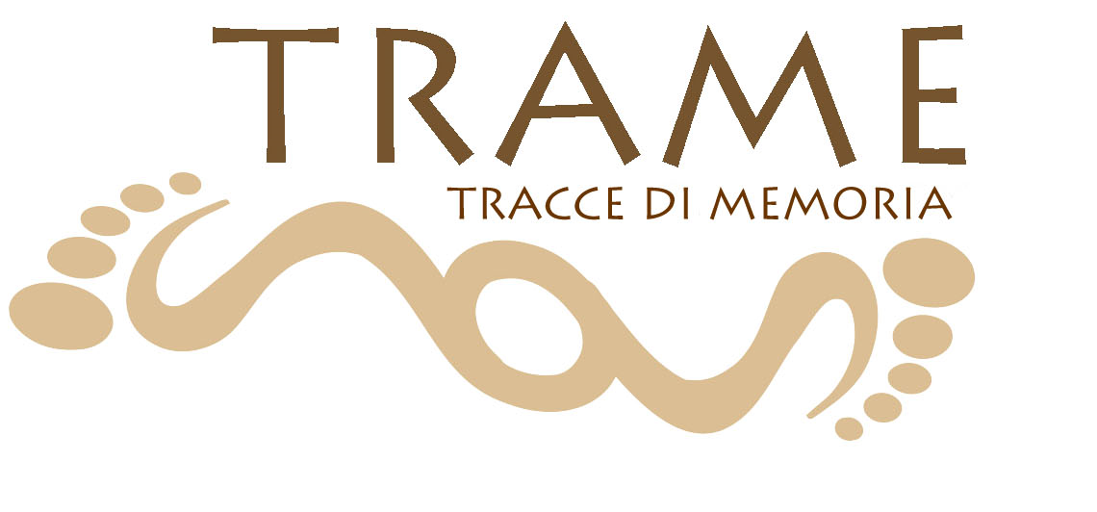
NEWSLETTER - APRIL 2022
Dear colleagues,
Here is our 10th newsletter on the project TRACCE DI MEMORIA – TRAME (2020-1-IT02-KA201-079794), co-funded by the Erasmus+ Programme of the European Union.
This newsletter is dedicated to the amazing results of TRAME transnational mobilities in Italy!
Transnational training activities were planned to test and validate the TRAME methodology and apply positive creative and practical ways of learning about cultural heritage, which were positively evaluated during the national pilot programmes.
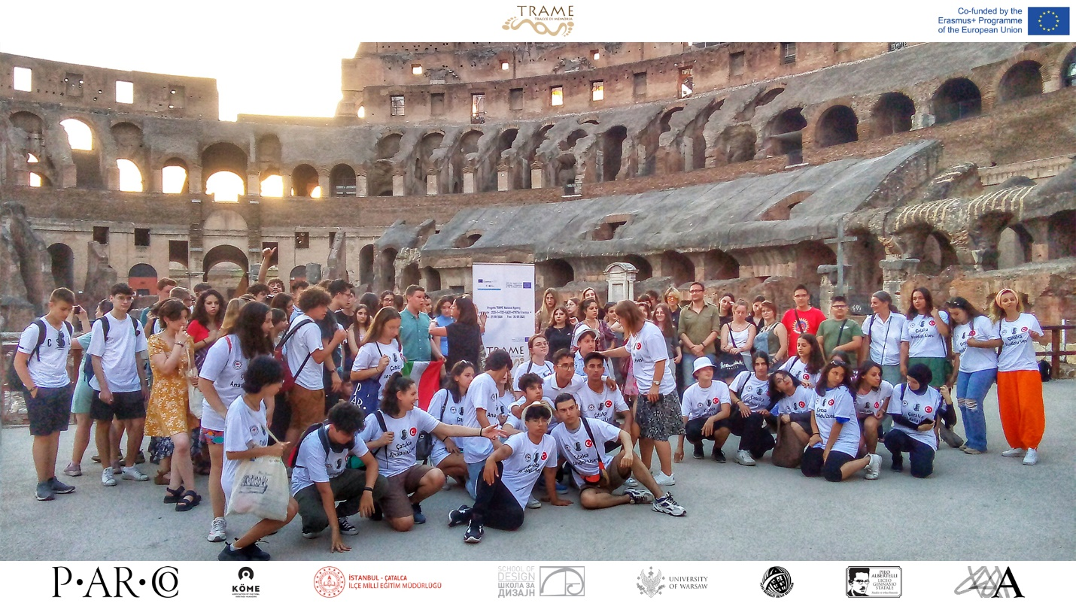
Transnational mobility Italy “NEVER ENDING JOURNEY”
Venue: The city of Rome
Period: 02-07 June 2022
Organization: Liceo Classico Pilo Albertelli and Parco archeologico del Colosseo
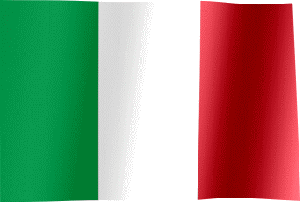
The TRAME exchange took place in Rome from June 2nd to 7th and began with sessions in the Curia Iulia, the Senate building at the center of the Roman Forum. 91 students from Hungary, Serbia, Turkey, and Italy split into five groups to write the words to a TRAME song composed by the students at the Albertelli School in Rome, tell stories of strangers in the Forum and inspired by Rome’s architecture and history, to create a video and written documentary of the exchange in Rome, and to organize the TRAME exhibition, which will be presented on 3 October 2022. The theme of the projects centered on “strangers in Rome” and the unique stories that immigrants brought on their travels in the ancient world.
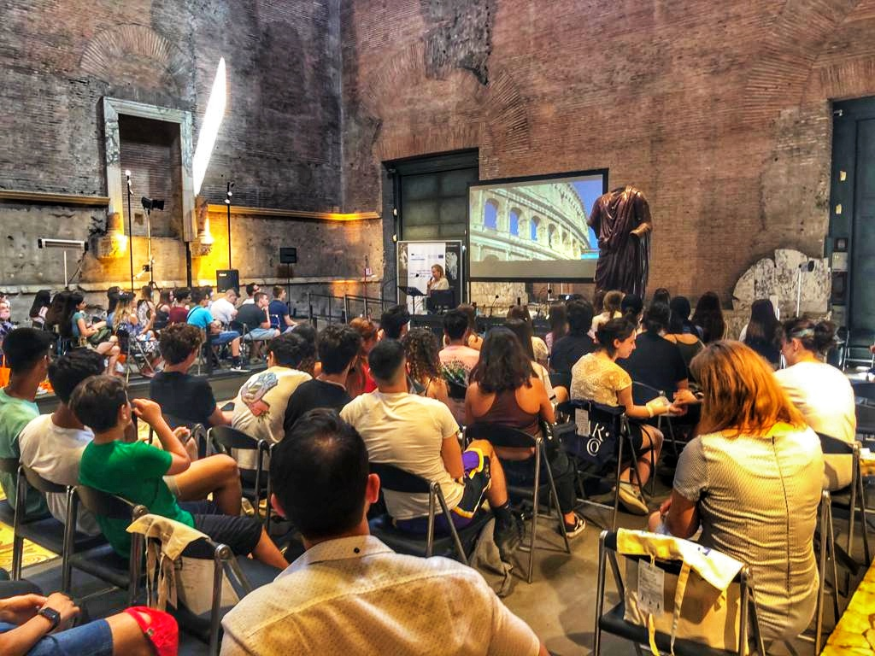
Throughout the week, the students worked on their projects in the morning and spent the afternoons exploring sites in Rome where immigrants lived, worked, and worshipped, and where different cultures mixed. They learned about foreigners in Rome during the 18th and 19th centuries in Piazza di Spagna, Trinità dei Monti, and Santa Maria Maggiore, a beautiful Spanish basilica in Rome’s Monti neighborhood. The next afternoon, they explored the area around the Colosseum, on the Aventine Hill and the Circus Maximus, where the ancient Romans held chariot races.
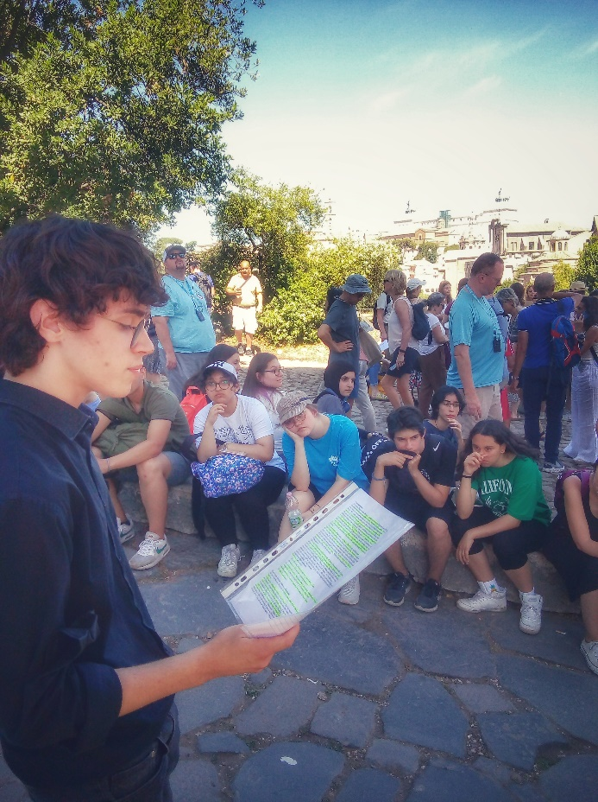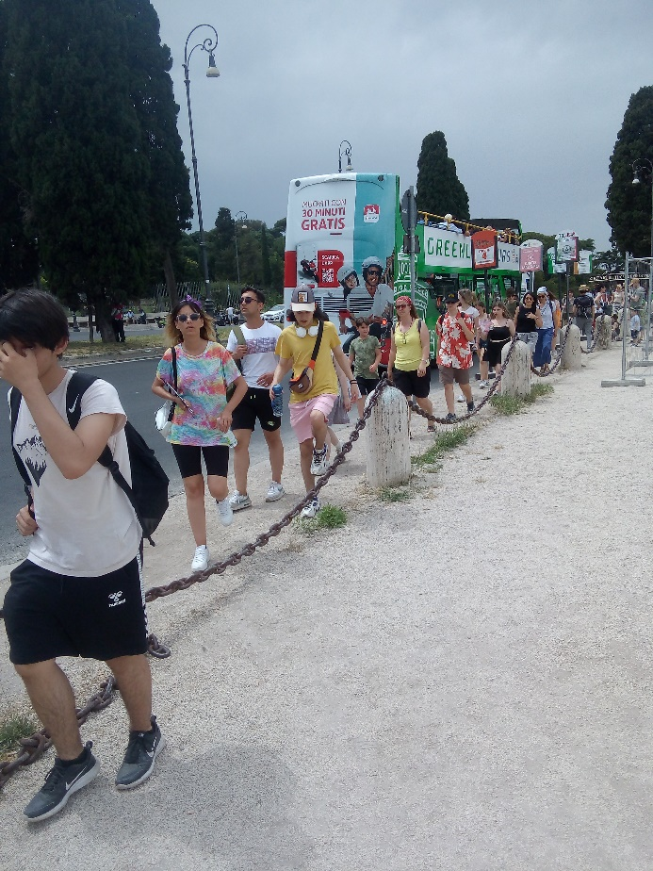
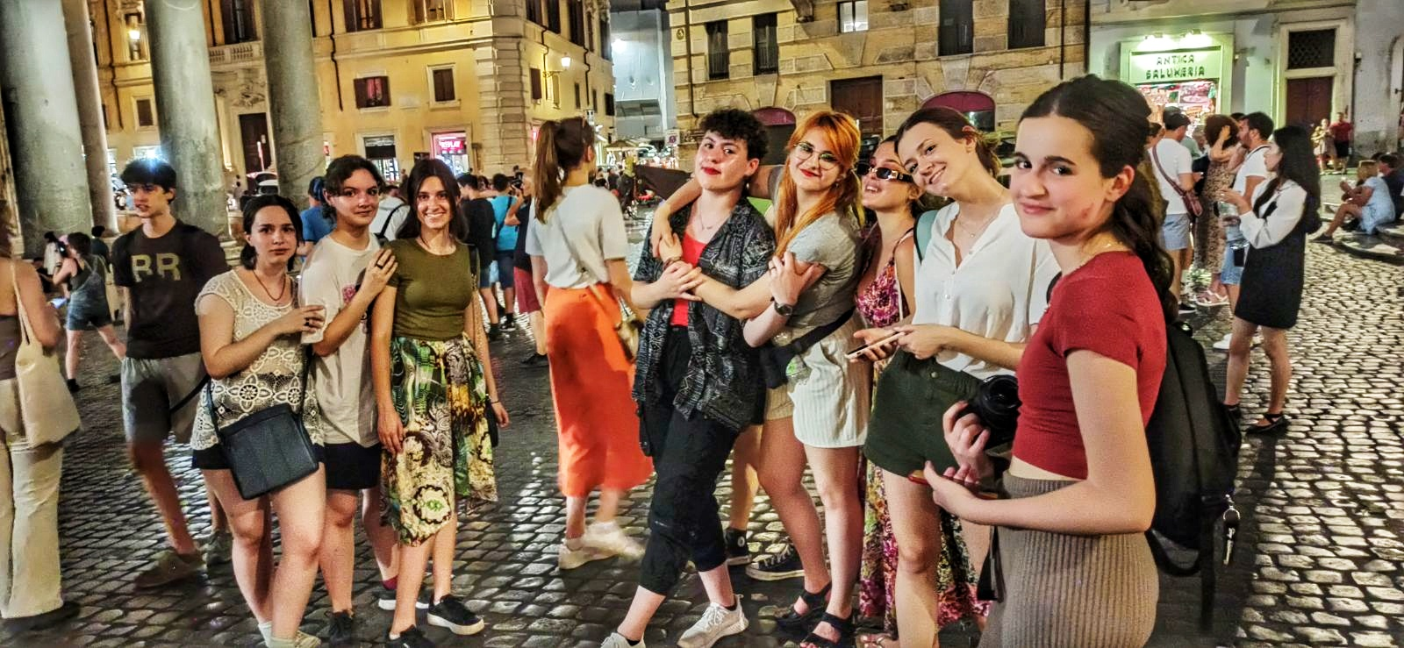
On Sunday they took a break from their projects and visited the Capitol building, seat of Rome’s municipality since the XIIth century. They sat in the council chamber of the historic Giulio Cesare Hall, walked through the Hall of Flags, and spoke to one of the councilors about TRAME’s mission and their time in Rome. On Monday, the students finished their projects and presented them to the group with pictures, videos, journals, PowerPoints, singing, and artistic illustrations. They received their TRAME certificates and took a special after-hours tour of the Colosseum at night!
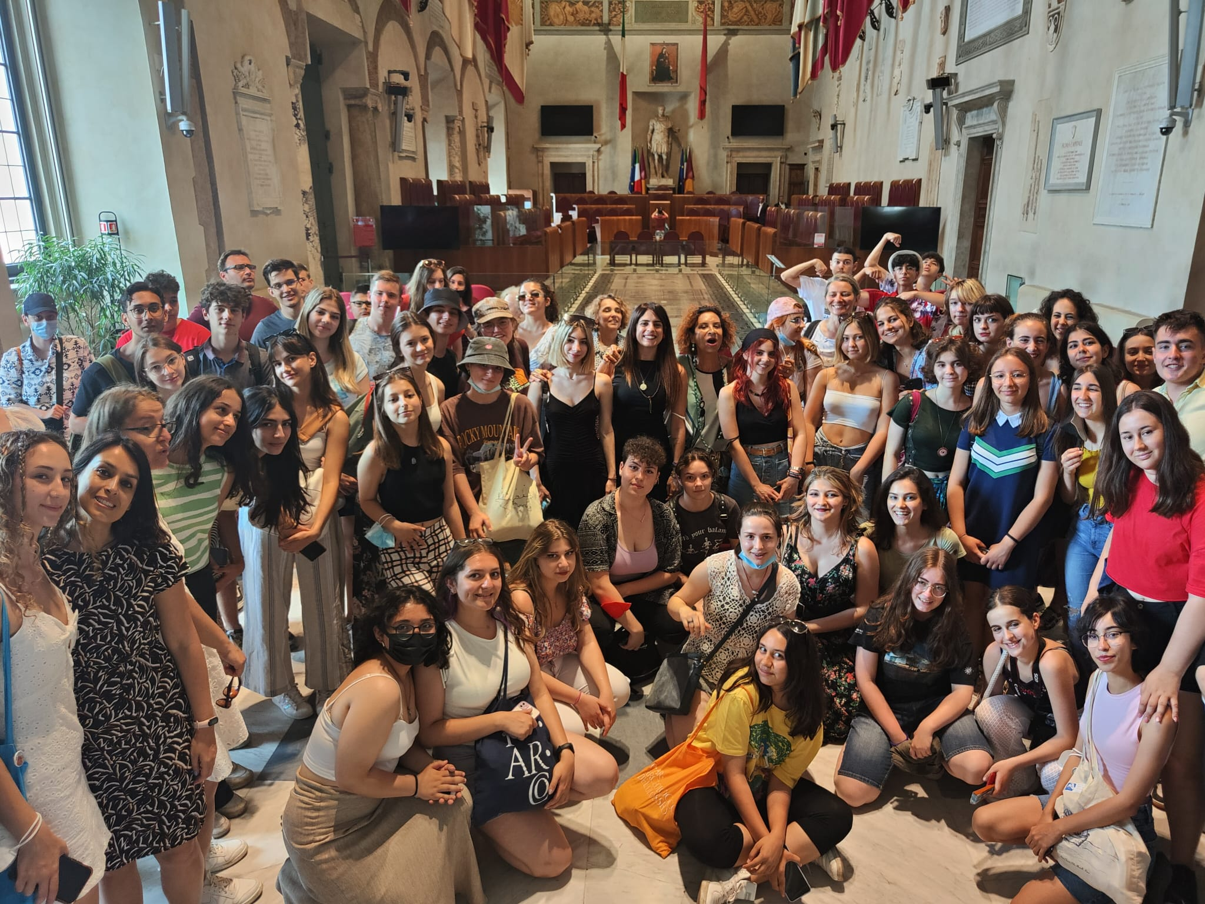
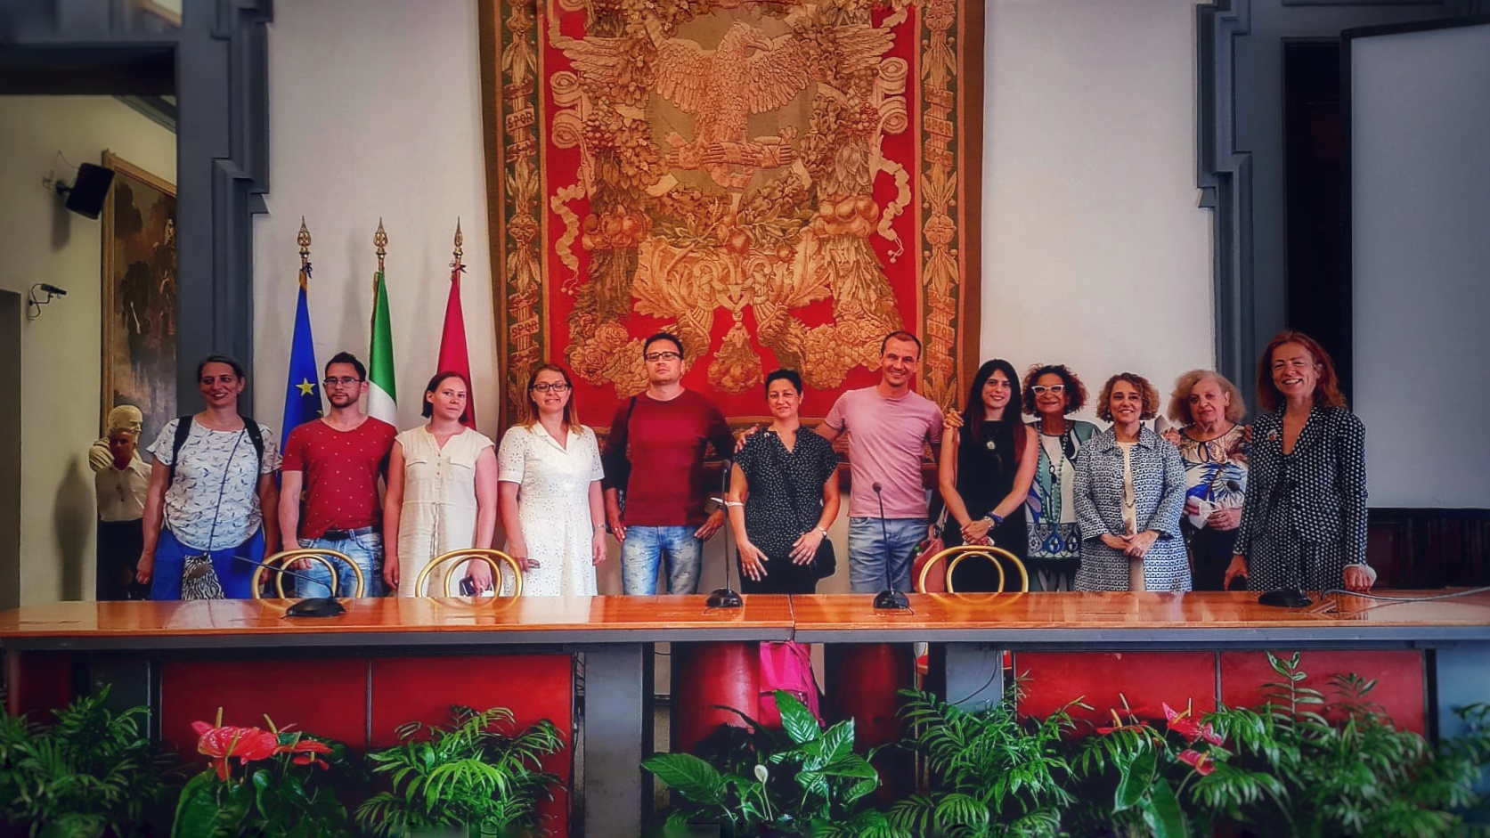
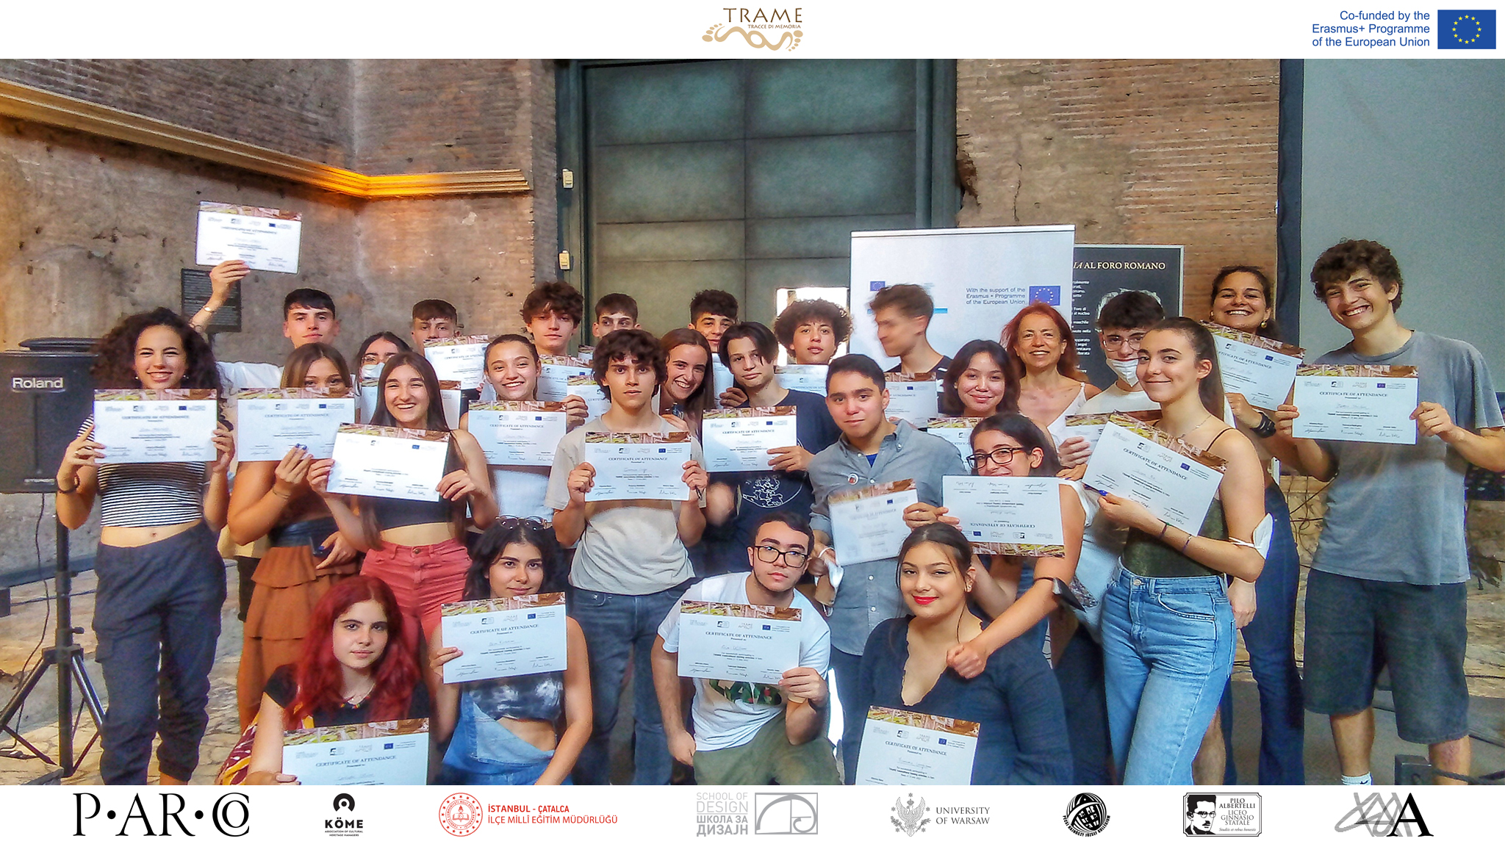
On the last day, the students from the Albertelli school in Rome led a tour of the Forum, which focused on sites that were important to foreigners, including the temple of Magna Mater, the Basilica Iulia, and the Arch of Titus.
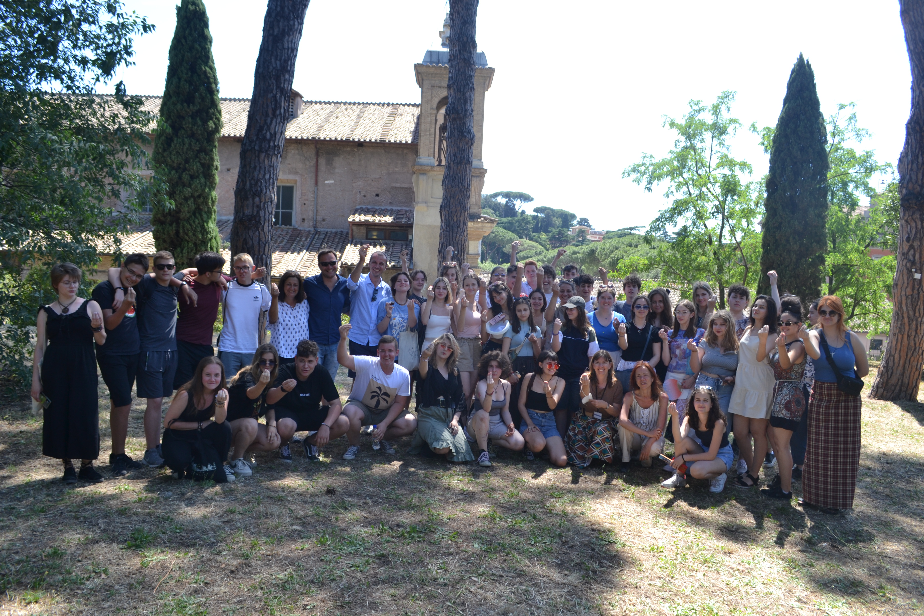
Students also participated in a photo contest with the topic “ancient and modern: multiculturality in Rome and in the Parco archeologico del Colosseo”. Students Anja Ćevriz, Maja Ignjatović, Andrej Mitrić, Nađa Milonić, Teodora Mihajlović and Visnja Lepšanović from the School of Design in Belgrade won the contest with their photo titled “the never-ending journey”. They said that “we wanted to show the importance of collecting memories with others, exploring other cultures, and following by the footsteps of ancient Romans”. A photo from Akın Kancevizoğlu from Turkey was the runner-up. Akın explained that “this photo tells us that even though we are different, we can live together without any problems. In the photo this is portrayed by showing a flower which represents the minorities because it is small and fragile, but the perspective shows it to be almost the same size as the church, which represents the majorities in Rome as it is big and strong”.
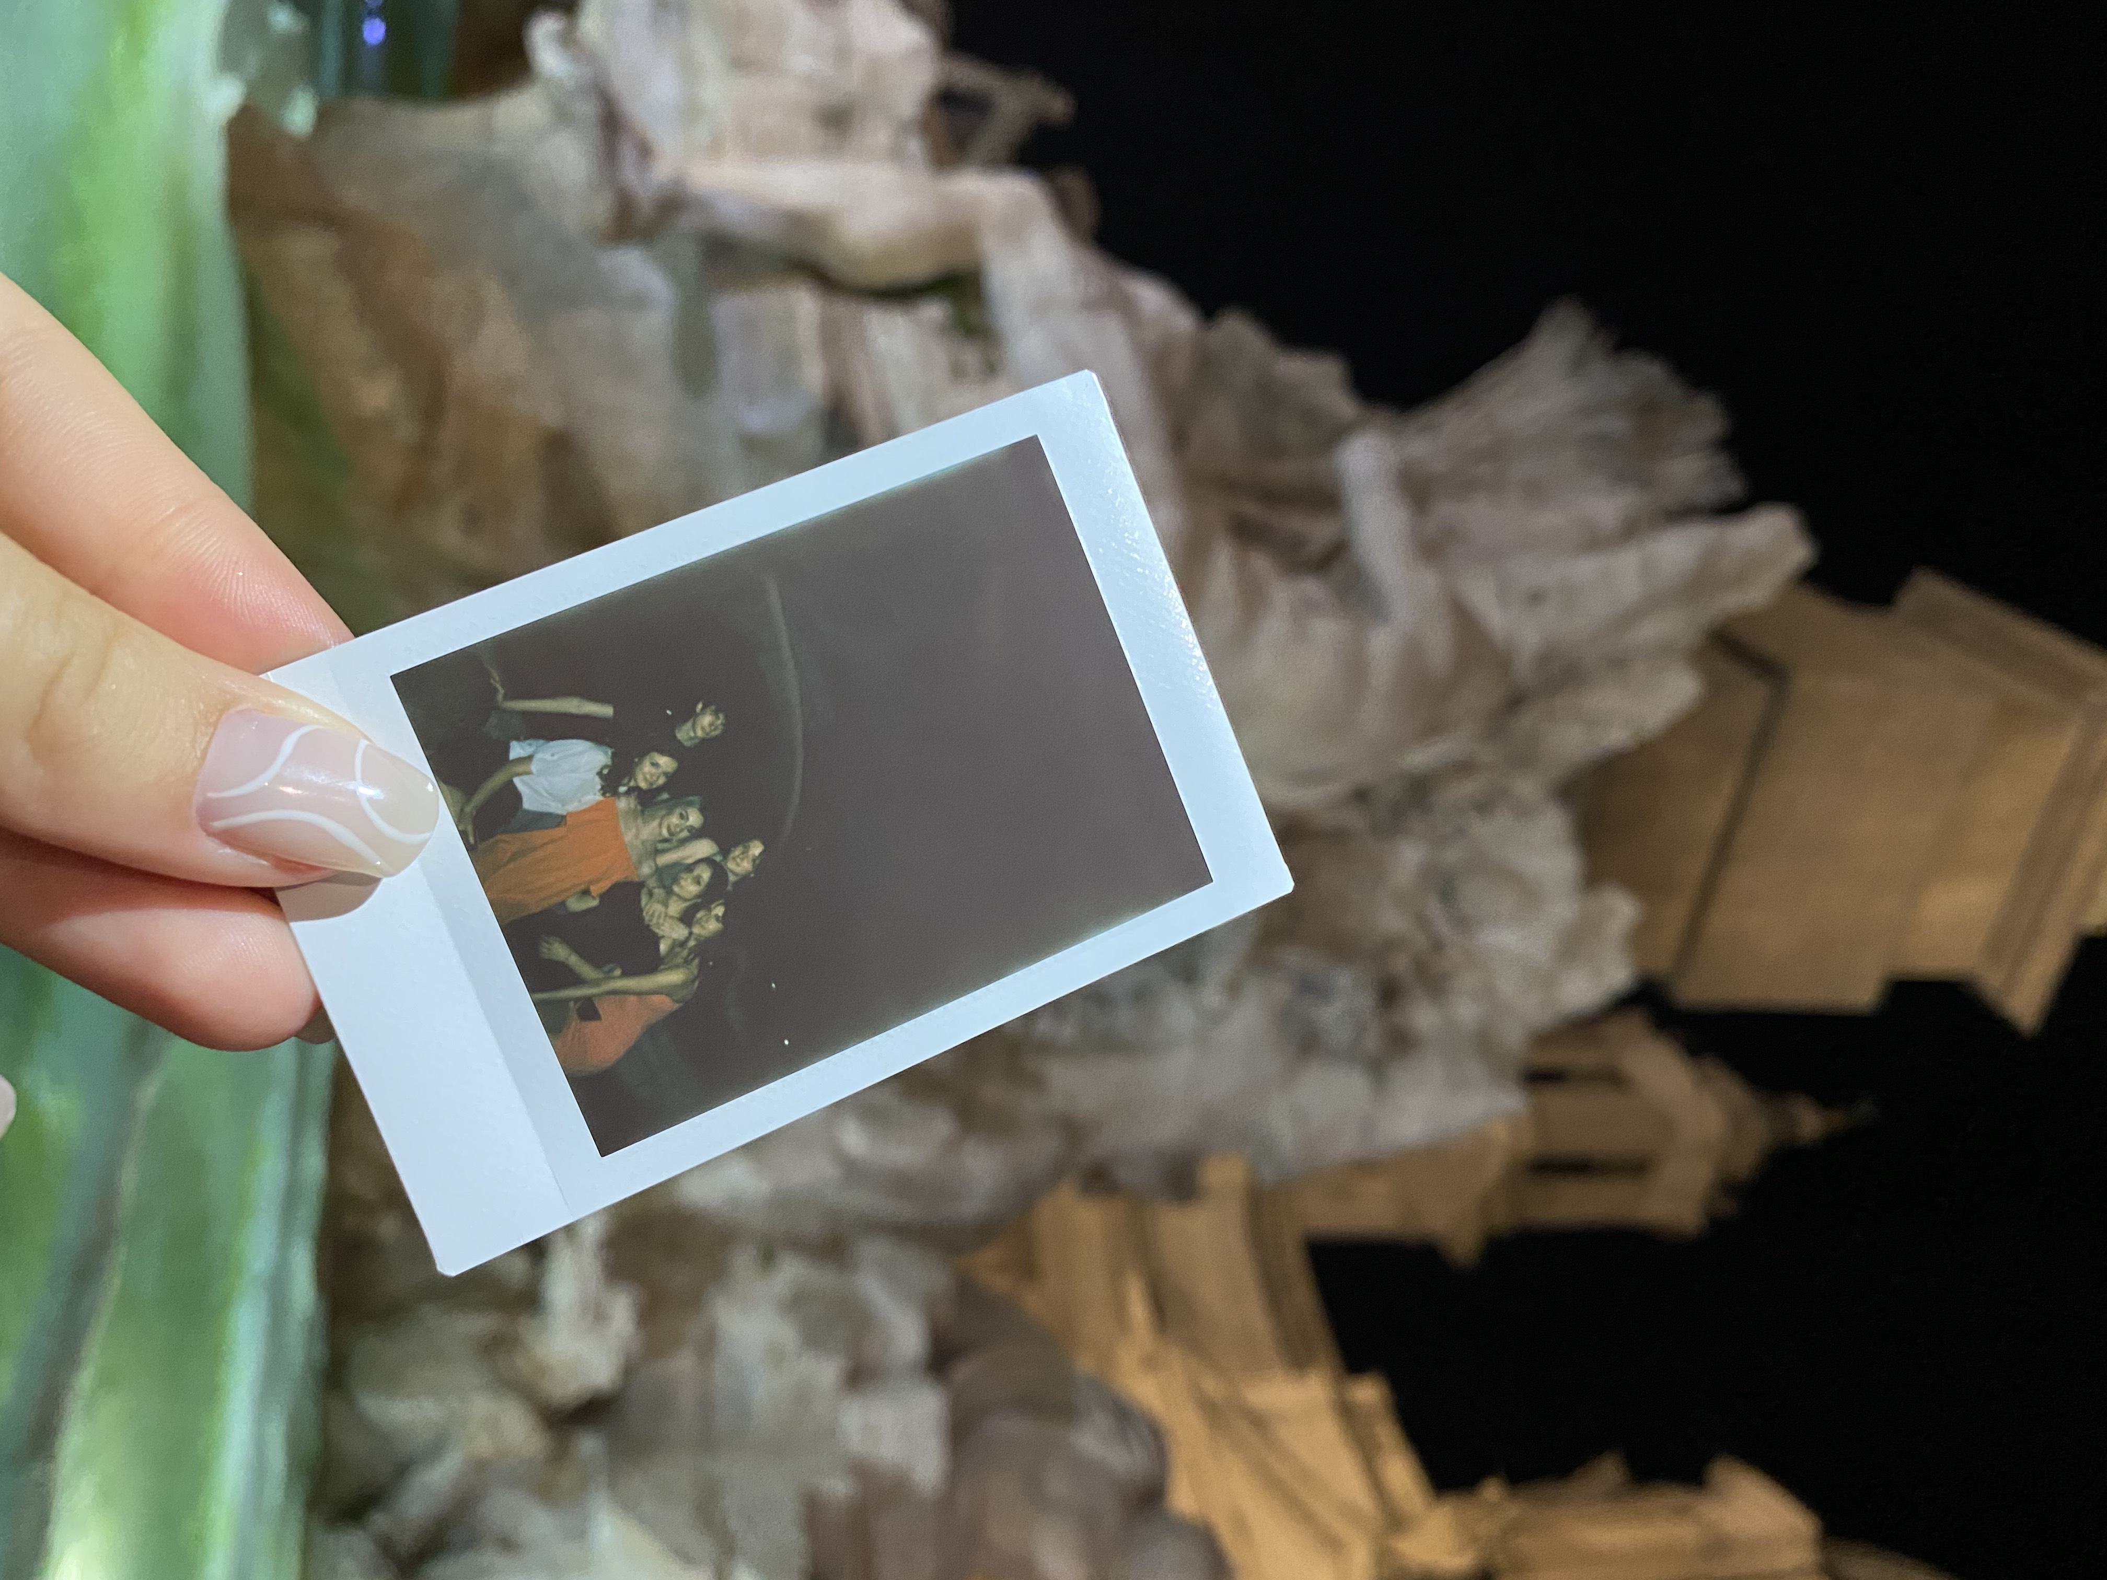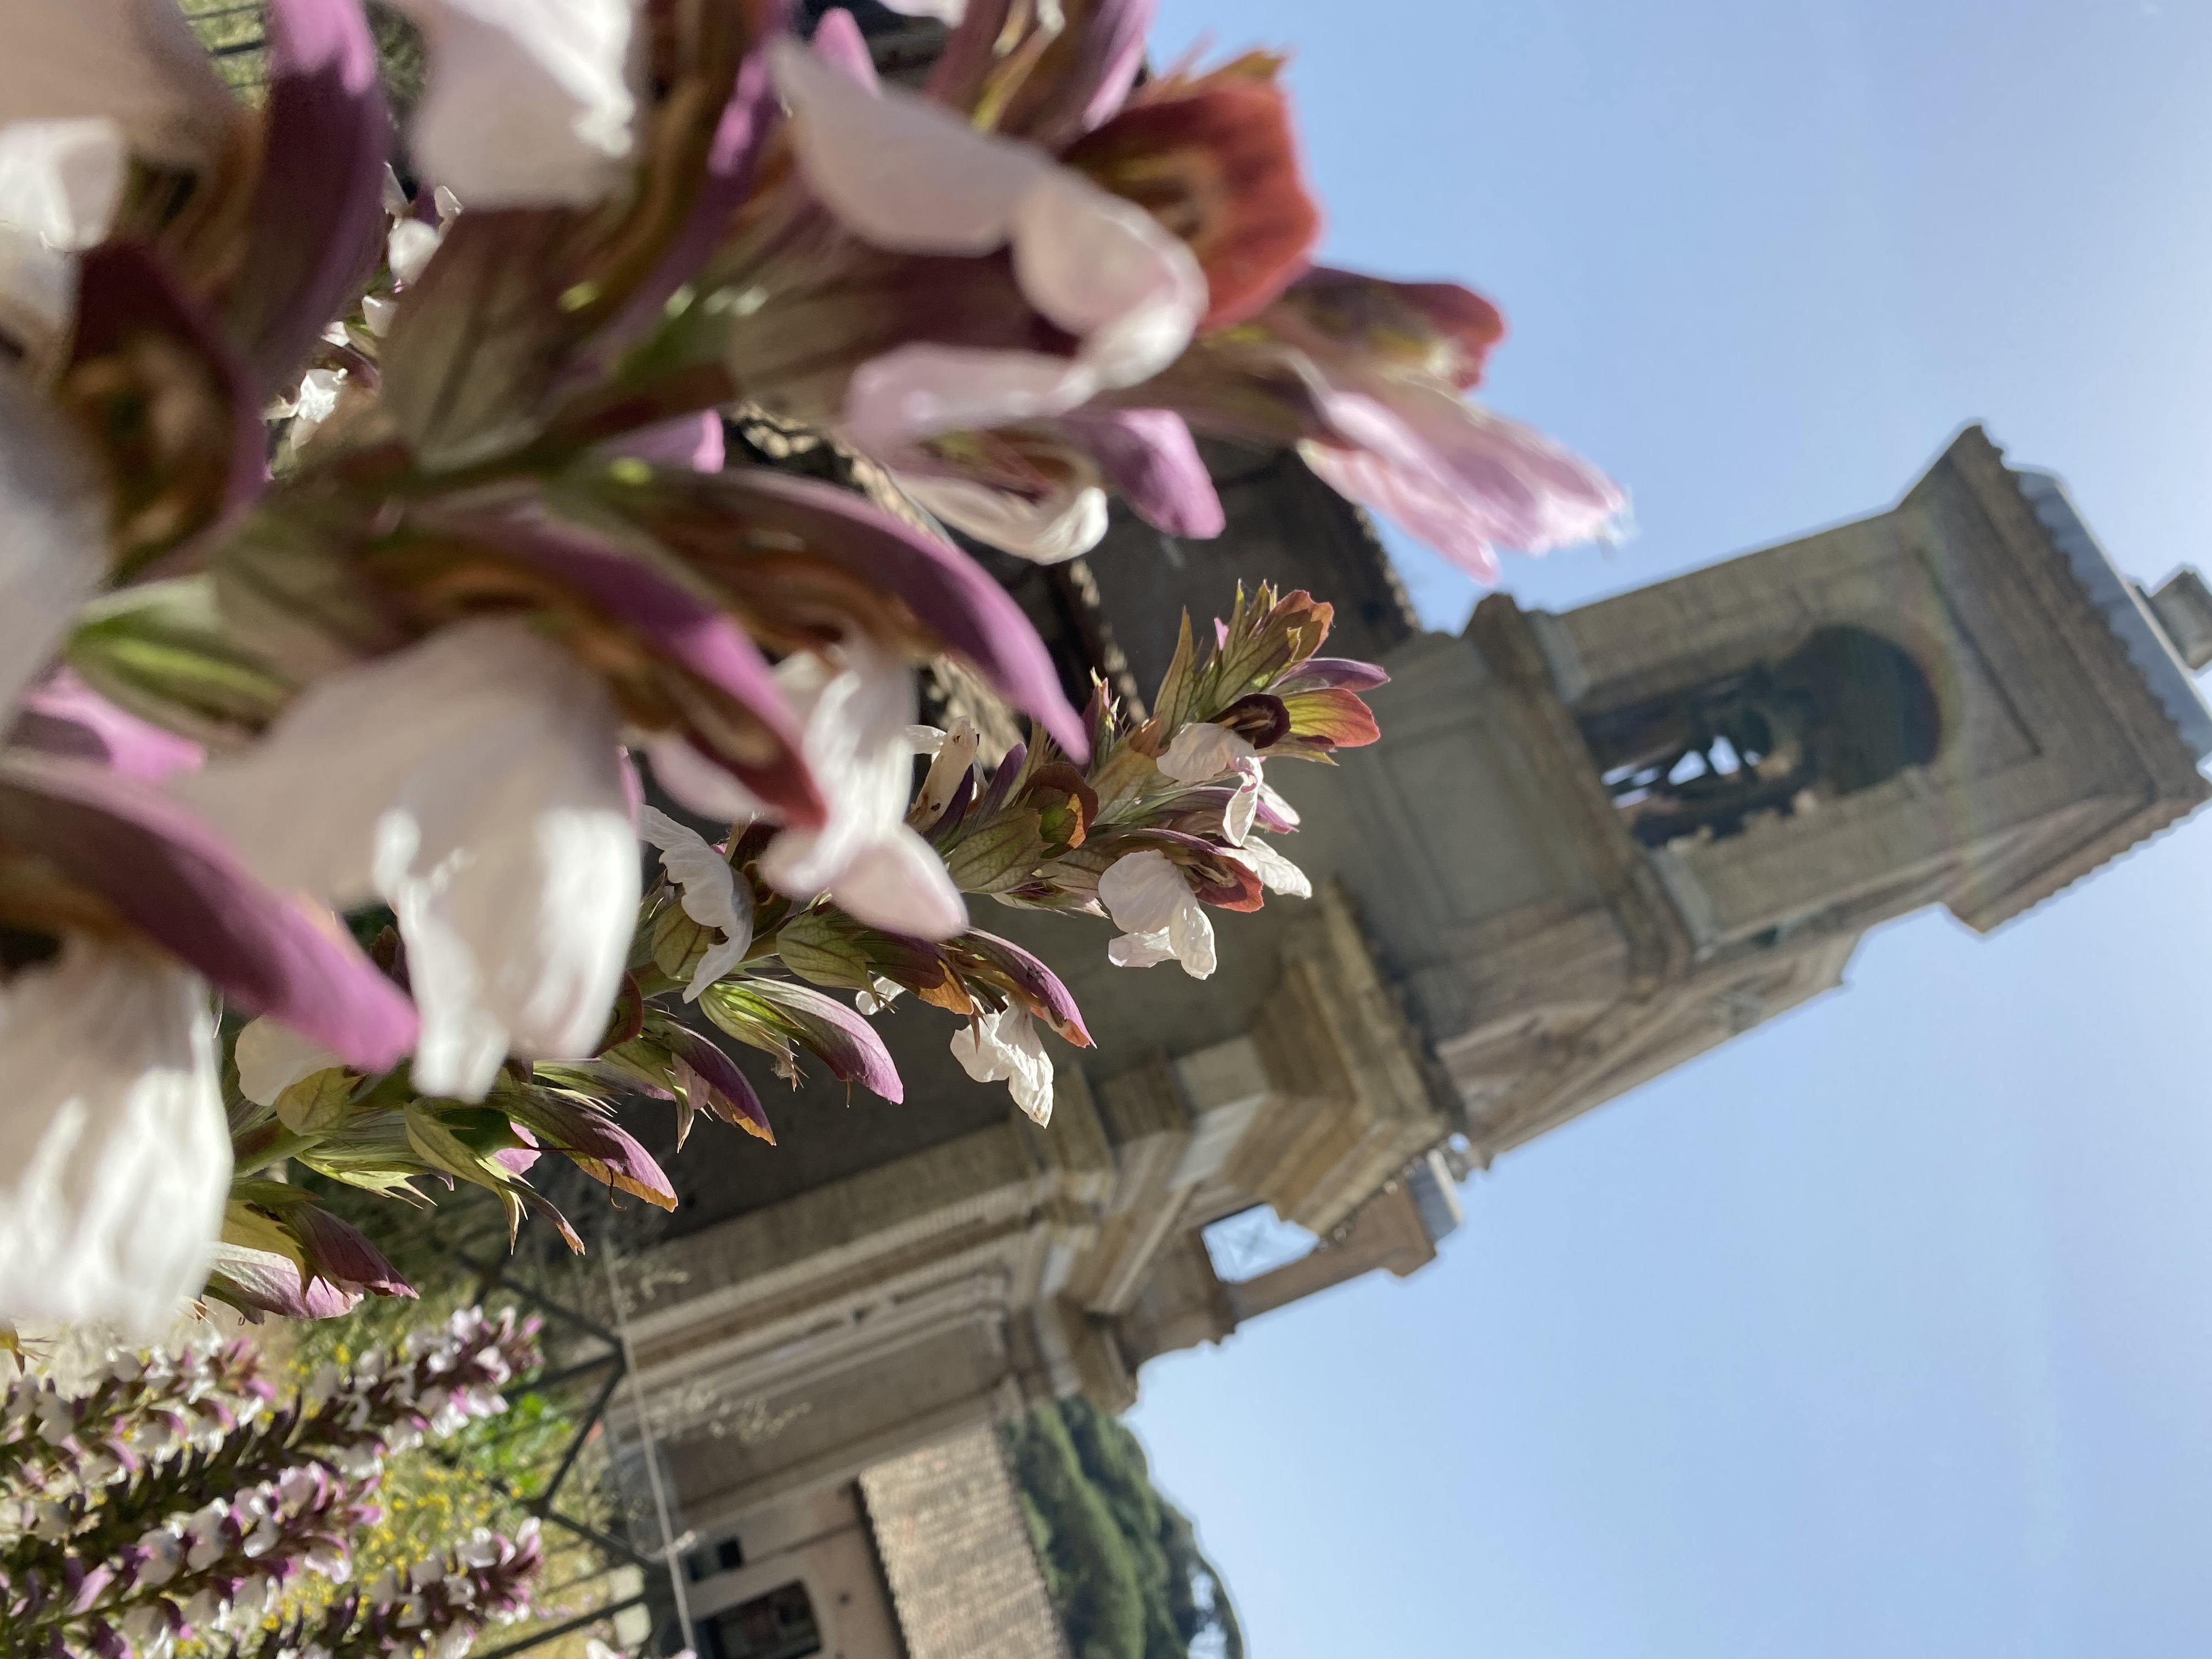
Finally, the students had lunch at the Church of St. Anastasia, and celebrated the end of the program.
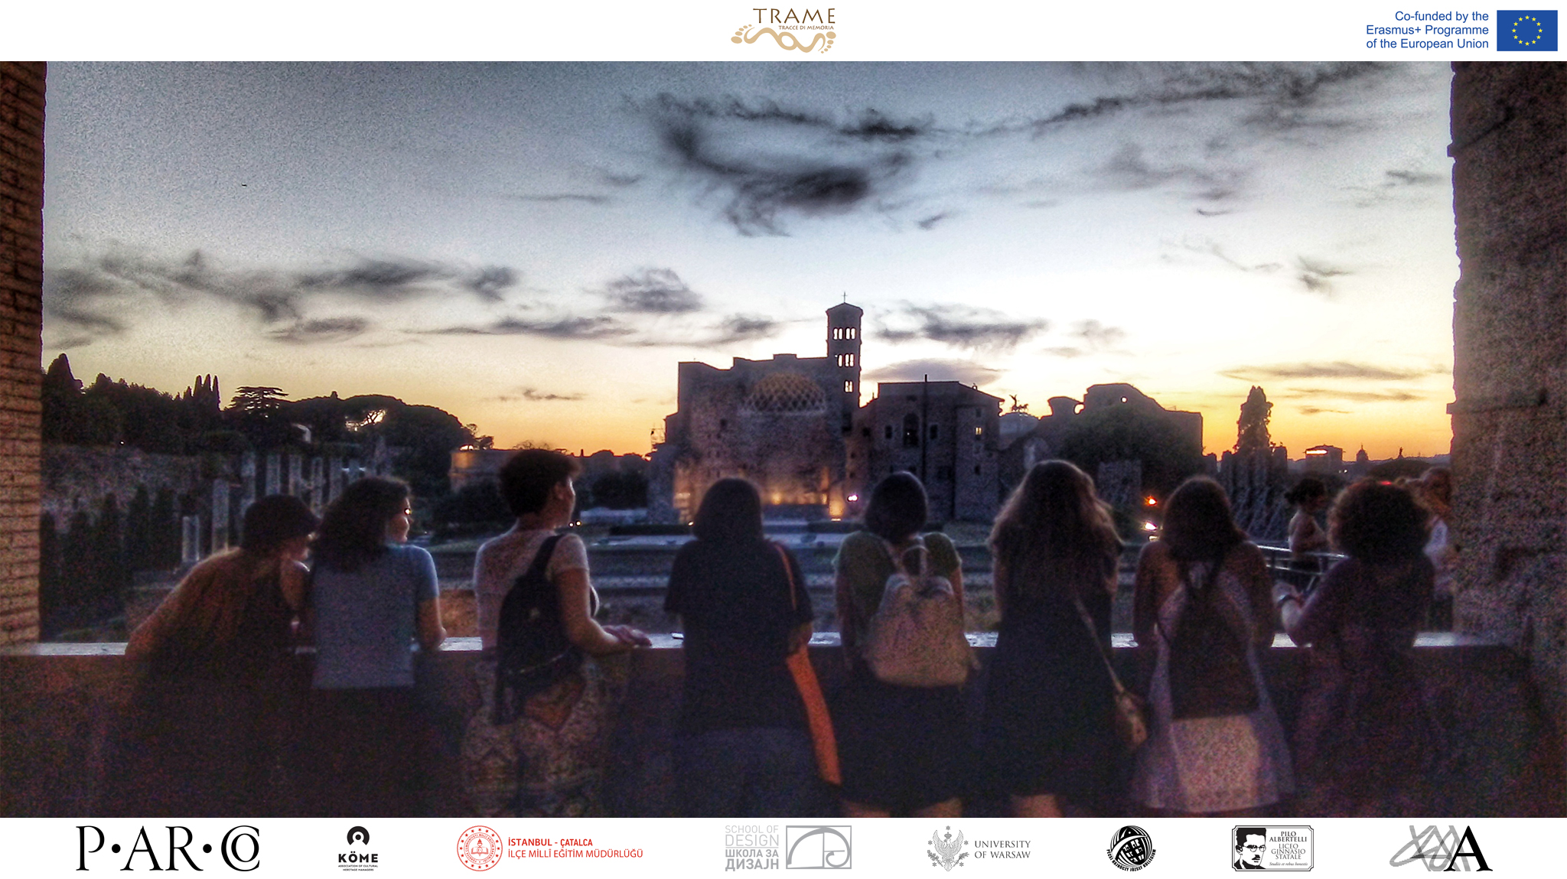

Great media support was given to this mobility programme and hereby we would like to thank Rivista City, a Quotidiano Beni Italiani Patrimonio Mondiale, AgCult, press agency focusing on culture, and Tuscia up, an online magazine of the Latium area.
Rivista City – TRAME – Tracce di Memoria al Parco Archeologico del Colosseo con gli studenti del liceo

Agenzia Cult – Progetto Trame, a giugno tappa al Parco archeologico del Colosseo

TusciaUp – “Ancient and modern. Multiculturality in Rome”, Erasmus Plus. 70 studenti di Turchia, Serbia e Ungheria al Parco archeologico del Colosseo’’

Also, the project TRAME was mentioned by Roma Capitale, official Facebook page of the city of Rome

Visit TRAME website
Subscribe to the newsletter
FOLLOW US ON SOCIAL MEDIA:
WP2 – Promotion and dissemination of TRAME results
Coordinator: Institute of Archaeology (RS)
institut@ai.ac.rs; j.andjelkovic@ai.ac.rs; jevtoviclj@gmail.com

In compliance with EU General Data Protection Regulation (GDPR) that came into effect on 25 May 2018, we hereby inform you that the personal data you provide to TRAME PROJECT is included in a file managed by PARCO ARCHEOLOGICO DEL COLOSSEO, Piazza di Santa Maria Nova 53, 00186, Roma, as Data Controller, on behalf of the – EU funded project – TRAME project’s partners, and used exclusively for dissemination of professional communications, newsletters, events or promotions organised directly by any of the TRAME project’s partners or by carefully selected third parties. You may revoke the consent you have given us at any time; Likewise, you may exercise your rights of access, rectification, cancellation and opposition free of charge by sending your request accompanied by the copy or data of your Personal Number to the email pa-colosseo.progettotrame@beniculturali.it In order to view our privacy policy and/or information about your Personal Data, the purposes and the parties the Data is shared with, visit the website https://trameproject.eu/ or contact pa-colosseo.progettotrame@beniculturali.it.

The European Commission’s support for the production of this publication does not constitute an endorsement of the contents, which reflect the views only of the authors, and the Commission cannot be held responsible for any use which may be made of the information contained therein. Specific info can be found here.

