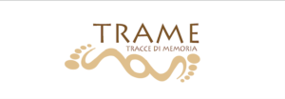

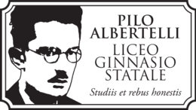

Tuesday 7 June: A guided tour Places frequented by foreigners in the forum in ancient times. A guided Tour

Group itinerary and directions

GROUP from Serbia 1- 5
GROUP from Turkey 2-5 and 1
GROUP form Hungary 3-5, 1-2
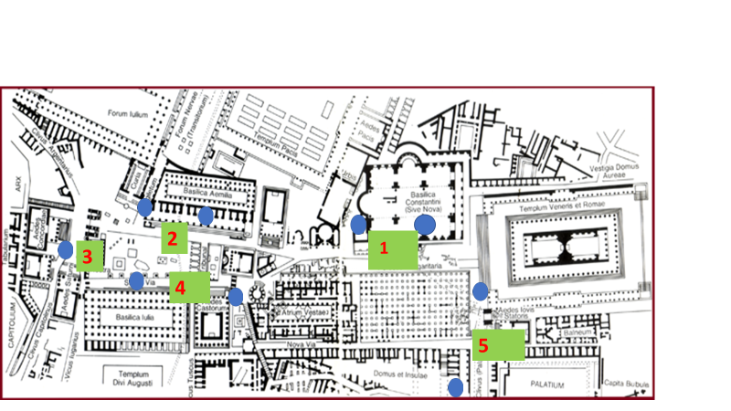

1 Prof.ssa CALCAGNO and 5 italian students
Olivieri: la basilica di Massenzio
Uffreducci, Kock, Sentinelli, Santoni: Horrea piperataria
2 Serbian/Hungarian or Turkish teacher and 5 italian students
Donatelli, Libriani, Di Fabio: Stationes municipiorum
Minorenti, Fiorentino: la basilica Emilia
3 Serbian/Hungarian or Turkish teacher and 3 italian students
Talamanca, Lo Faso, Attanasio: Campidoglio
4 Prof.ssa MARASCIALLI and 5 italian students
Naro, Zupi Versari: la basilica Iulia
Denti, Arcà, Albano, Grasso: Vicus Tuscus
5 Prof.ssa NOCITA and 7 italian students
Foti, Liberati, Campisano, Zannoni: Tempio della Magna Mater
Scatena, Croppo, Stacchini: ludi Gallicus, Dacicus e Matutinus
